**Registration & Orientation**

Administrative preparation to take a course offered on the Buzzjuice Courses platform. This course will allow students to become acquainted with the course platform. Registration enables student support though their course and prepares the Buzzjuice Courses platform to take prospective students through the learning process.

**Welcome to Buzzjuice Courses!**

…. a revolutionary academic system in educational and lifestyle development.

Members must complete all the lessons in this orientation to pass the following Registration & Orientation Assessment. The courses page can be accessed by tapping on the ‘Courses’ icon in the bottom menu. The courses page provides a list of courses and lessons (with topics, assignments and quizzes), discussion forums and groups. New courses, topics, lessons and quizzes can be created by members with the *Gold Agent membership plan.*

**Introduction & Welcome**

**Welcome to the Blue Crown Academy Registration & Orientation!**

New members would need resource the following:

* Access to a device with stable internet availability for streaming videos and online lessons
* An address (preferably P.O. Box) to receive registration and course packages
* Details of the last educational institution you enrolled in (Name, dates and course taken)
* A clear photo or legible scan of your ID (required to verify qualifications and affiliate payments)
* A clear photo or legible scan of your health insurance or details of the nearest health center
* Details of the nearest educational institution that can provide study support (library, class room, study area, registration support).

**Institutional Collaboration**

To support the tangible services that members of the academy may require for the online courses, such as library services, internet access, study areas and examination facilitation, the academy requires members to identify with the nearest educational institution to them. The institution selected must have the potential to provide you with study support through the duration of your registration with Blue Crown Academy.

**Academy Timetable**

The academy timetable distributed in this lesson supports lifestyle and study schedule planning; “Plan your time, or someone will plan your time for you!”. The columns in the timetable represent days whilst the rows determine the time from 7am. The sample timetable below shows the Registration & Orientation class occurring on Mondays from 7:45am to 9am. Recovery Dynamics class takes place on Tuesdays from 9:15am to 10:30am.

|  |  |  |  |  |  |  |
| --- | --- | --- | --- | --- | --- | --- |
| **TIME** | **MONDAY** | **TUESDAY** | **WEDNESDAY** | **THURSDAY** | **FRIDAY** | **SATURDAY** |
| **07:00** |  |  |  |  |  |  |
| 07:15 |  |  |  |  |  |  |
| 07:30 |  |  |  |  |  |  |
| 07:45 | REGISTRATION & ORIENTATION |  |  |  |  | DAILY DEVOTION |
| **08:00** |
| 08:15 |
| 08:30 |
| 08:45 |
| **09:00** |  |  |  |  |  |  |
| 09:15 |  | RECOVERY DYNAMICS | DRIVING I – BASIC THEORY | ELECTIVE I – THE WORLD OF SKILL |  |  |
| 09:30 |
| 09:45 |
| **10:00** |
| 10:15 |

See if you can identify the day and time of the other classes o the timetable above. A blank timetable template has been posted below for you to print. This would help to organize your classes and lifestyle activities.

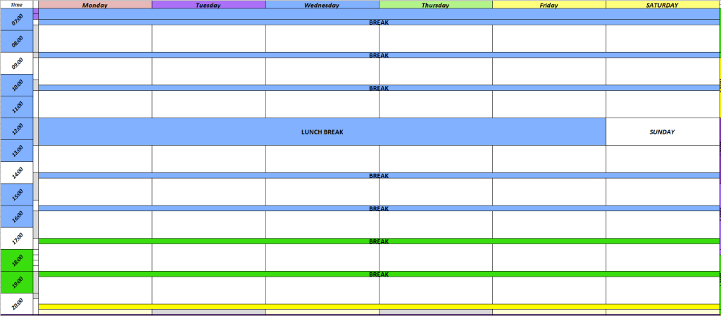

Tap and hold or right click on the timetable to save the picture or open it in a new browser tab. It would be easier to print or edit it once saved to your device.

**Academy Bylaws**

The Academy’s [*bylaws*](https://127.0.0.1/buzzjuice.net/academy/forum/bylaws/) are based on the [*Koware bylaws*](https://127.0.0.1/buzzjuice.net/academy/forum/bylaws/) that can be viewed at this link URL: <https://127.0.0.1/buzzjuice.net/academy/forum/bylaws/>

The bylaws include the following sections:

* [Terms](https://127.0.0.1/buzzjuice.net/academy/discussion/bylaws-terms/)
* [Conditions](https://127.0.0.1/buzzjuice.net/academy/discussion/bylaws-conditions/)
* [Rules](https://127.0.0.1/buzzjuice.net/academy/discussion/bylaws-rules/)
* [Regulations](https://127.0.0.1/buzzjuice.net/academy/discussion/bylaws-regulations/)
* [Privacy](https://127.0.0.1/buzzjuice.net/academy/discussion/bylaws-privacy/)
* [Policies](https://127.0.0.1/buzzjuice.net/academy/discussion/bylaws-policies/)
* [Procedures](https://127.0.0.1/buzzjuice.net/academy/discussion/bylaws-procedures/)
* [Torah Bylaws](https://127.0.0.1/buzzjuice.net/academy/discussion/constitutions-of-leviticus/)

These bylaws are in a discussion forum format to enable the development of the bylaws by the members. Amendments to any part of the bylaws, except for the Torah Bylaws, are voted on and approved by the governing board of the academy and Koware. The Torah Bylaws are for reference and study purposes only. We encourage members to view the bylaws periodically and make their contributions to develop them. All clubs and groups are subject to these bylaws.

**Courses & Electives**

There number of professions in the contemporary world today are increasing as new courses and discoveries are developed and distributed through institutions. Did you know there are Professional Sleepers who are paid to sleep (ref: <https://ca.indeed.com/Professional-sleeper-jobs/> ). An online search for ‘types of professions’ would yield a multitude of results, all requiring qualifications obtained from course sitting, certificates and experience. It is never too late to start a new career; read about [KFC’s founder *Colonel Harland Sanders*](https://wikipedia.org/wiki/Colonel_Sanders).

In this topic we are going to do some research on a few of the assorted types of professions out there and their associated qualifications. Here is a list of current sites that readily provide a healthy and up to date list of professions and their associated certified courses:

* [IIE Passport](https://iiepassport.org/)
* [My Majors](https://www.mymajors.com/)
* [Career Planner](https://www.careerplanner.com/)
* [Career Profiles](https://www.careerprofiles.info/)

There are many more sites providing data on courses and profession that you can research on in your own time.

Opt to take an online career test to find out your best fit. According to *[Careerizma](https://www.careerizma.com/)*, it would be a good idea to take the following steps before taking any online career assessment.

Steps to matching with a career

* Evaluate yourself
  + Personality
  + Interests
  + Favorite Subjects
  + Skills
  + Education
  + Target Lifestyle
* List down the possible careers
* Choose your career

More details on these steps can be found on the *[Careerizma](https://www.careerizma.com/)* site.

The following sites can be used for career assessment tests:

* [Your Free Career Test](https://www.yourfreecareertest.com/)
* [Career Addict](https://www.careeraddict.com/)

There are more sites to take career tests on. It would be good to take as many tests as you can to identify the best career for you. Make a list of the suggested careers from each test and see what career pops up the most. Compare the results with your initial career choice in the last step to come to a conclusion on the best career for you.

**For this assignment,**

* Choose any one profession of your choice and create a list of about 20 questions to interview an individual in that field. The interviews can be conducted in person, on a call, online meeting, through email or postal surveys. However may be convenient for you.
* Write a report on the profession addressing the responses of the professional interviewed.
* The report should be *typed, doubled spaced, size 14pt text and no more than 2 pages*. The 2 page report must be submitted with the 1 page questionnaire making *3 pages submitted in total*. Name and date must be in the header. A cover page is not required.

**\***Please note that this assignment is not due immediately and is not required to complete or pass this registration & orientation. The assignment, however, must be completed and submitted to the academy by the end of any course taken with the academy. This must be done before any certificates can be issued.

**Club Groups & Leisure**

The academy hosts a variety of club groups and leisure activities. Members with an active Silver Lifestyle subscription can create clubs, groups and forums including making other posts such as articles, audio podcasts and events. All club groups and forums must abide with the Koware bylaws to avoid suspension or being removed. The creators of club groups and forums are responsible for the conduct of their members. Creators can be banned from the academy for misconduct.  
  
The academy also hosts games and other activities that may reward members with prizes such as the Buzzjuice Raffle. The raffle is held once a term, at the end of the term, and winners are credited with Palmier Points. Members gain raffle entries through their activities with Koware online and offline. The offline entries can be issued at Koware meetups or through lucky service cards. The more entries a user has can increase the chances of winning but does not guarantee winning. The raffle is a random draw.

Feel free to join any club group and participate in any leisure activities that would be published during the terms.

# Academy Events

{{todo}}

# Cooperative Agency

{{todo}}

# Registration & Orientation Assessment

This assessment will test your aptitude on what you can recall from the Registration & Orientation session. The assessment will automatically submit and end after 1 hour.

Good luck!

1. Do you have access to a device with stable internet connectivity for streaming videos and online classes?

 Yes, a mobile phone

 Yes, a tablet or phablet

 Yes, a laptop or laptab

 Yes, a desktop computer PC

 Yes, another type of device

 No, I don't have access to a device

1. At what address would you prefer to receive academy and course material?



*This response will be awarded full points automatically, but it can be reviewed and adjusted after submission.*

1. What is your highest level of education?

 Post Graduate

 Master's Degree

 Bachelor Degree

 College Diploma

 High School Certificate

 Other

1. What is the name of the most recent educational institution you were enrolled at?



*This response will be awarded full points automatically, but it can be reviewed and adjusted after submission.*

1. What year did/will you graduate from the institution?



*This response will be awarded full points automatically, but it can be reviewed and adjusted after submission.*

1. What course are/were you enrolled in at the institution?



*This response will be awarded full points automatically, but it can be reviewed and adjusted after submission.*

1. What is your academic or professional field of interest?



*This response will be awarded full points automatically, but it can be reviewed and adjusted after submission.*

1. Do you have Health Insurance?

 Yes, I have private Health Insurance

 Yes, I have National Health Insurance

 Yes, I have another type of Health Insurance

 No, I do not have any Health Insurance plan.

1. What is the name of your nearest local or preferred medical treatment center in your area?



*This response will be awarded full points automatically, but it can be reviewed and adjusted after submission.*

1. What is the name of the nearest preferred institution in your location that could possibly provide you with study support whilst registered with Blue Crown Academy?



*This response will be awarded full points automatically, but it can be reviewed and adjusted after submission.*

1. What area and town (or nearest city) is the institution located in?



*This response will be awarded full points automatically, but it can be reviewed and adjusted after submission.*

1. Name one of any course or program the institution offers that you might be interested in.



*This response will be awarded full points automatically, but it can be reviewed and adjusted after submission.*

1. What are the contact details of your nearest preferred institution? (Contact person, phone number, email, website)



*This response will be awarded full points automatically, but it can be reviewed and adjusted after submission.*

1. Review the following timetable and state what day and time the Daily Devotion lesson would take place.

|  |  |  |  |  |  |  |
| --- | --- | --- | --- | --- | --- | --- |
| **TIME** | **MONDAY** | **TUESDAY** | **WEDNESDAY** | **THURSDAY** | **FRIDAY** | **SATURDAY** |
| **07:00** |  |  |  |  |  |  |
| 07:15 |  |  |  |  |  |  |
| 07:30 |  |  |  |  |  |  |
| 07:45 | DAILY DEVOTION |  |  | ELECTIVE I – THE WORLD OF SKILL | REGISTRATION & ORIENTATION |  |
| **08:00** |
| 08:15 |
| 08:30 |
| 08:45 |
| **09:00** |  |  |  |  |  |  |
| 09:15 | RECOVERY DYNAMICS |  | DRIVING I – BASIC THEORY |  |  |  |
| 09:30 |
| 09:45 |
| **10:00** |
| 10:15 |

 Thursdays, 7.00 to 10.15

 Mondays, 8.00 to 9.00

 Fridays, 8.00 to 9.00

 Mondays, 7.45 to 9.00

 The lesson takes place daily

1. State all the categories of bylaws maintained by Blue Crown Academy.



1. At what stage does it become too late to start on a new career?

 When one has already started on a career

 When one is too old

 When one has not completed a previous career

 When one loses their job or gets a new job

 It is never too late to start a new career

1. Have you prepared a CV/resume before?

 Yes

 No

 I am currently preparing one.

 Someone is currently preparing one for me

 Someone has prepared one for me

1. What type of members are allowed to create club groups and forums?

 Classic Lifestyle Members

 Silver Lifestyle Subscribers

 Jewel Affiliate Members

 Gold Agent Members

 Platinum Partners

1. Members with the most raffle entries are most likely to win the raffle.

 They are guaranteed winners

 This is true, they are most likely to wiin

 It is more difficult for them to win

 Every member has an equal chance to win the raffle at the end of the term.

 Members can win the raffle only if they have enough points to enter the raffle.

1. Members can get raffle entries through service card codes.

 True

 False